**ASSIGNMENT-3**

Slave-1:

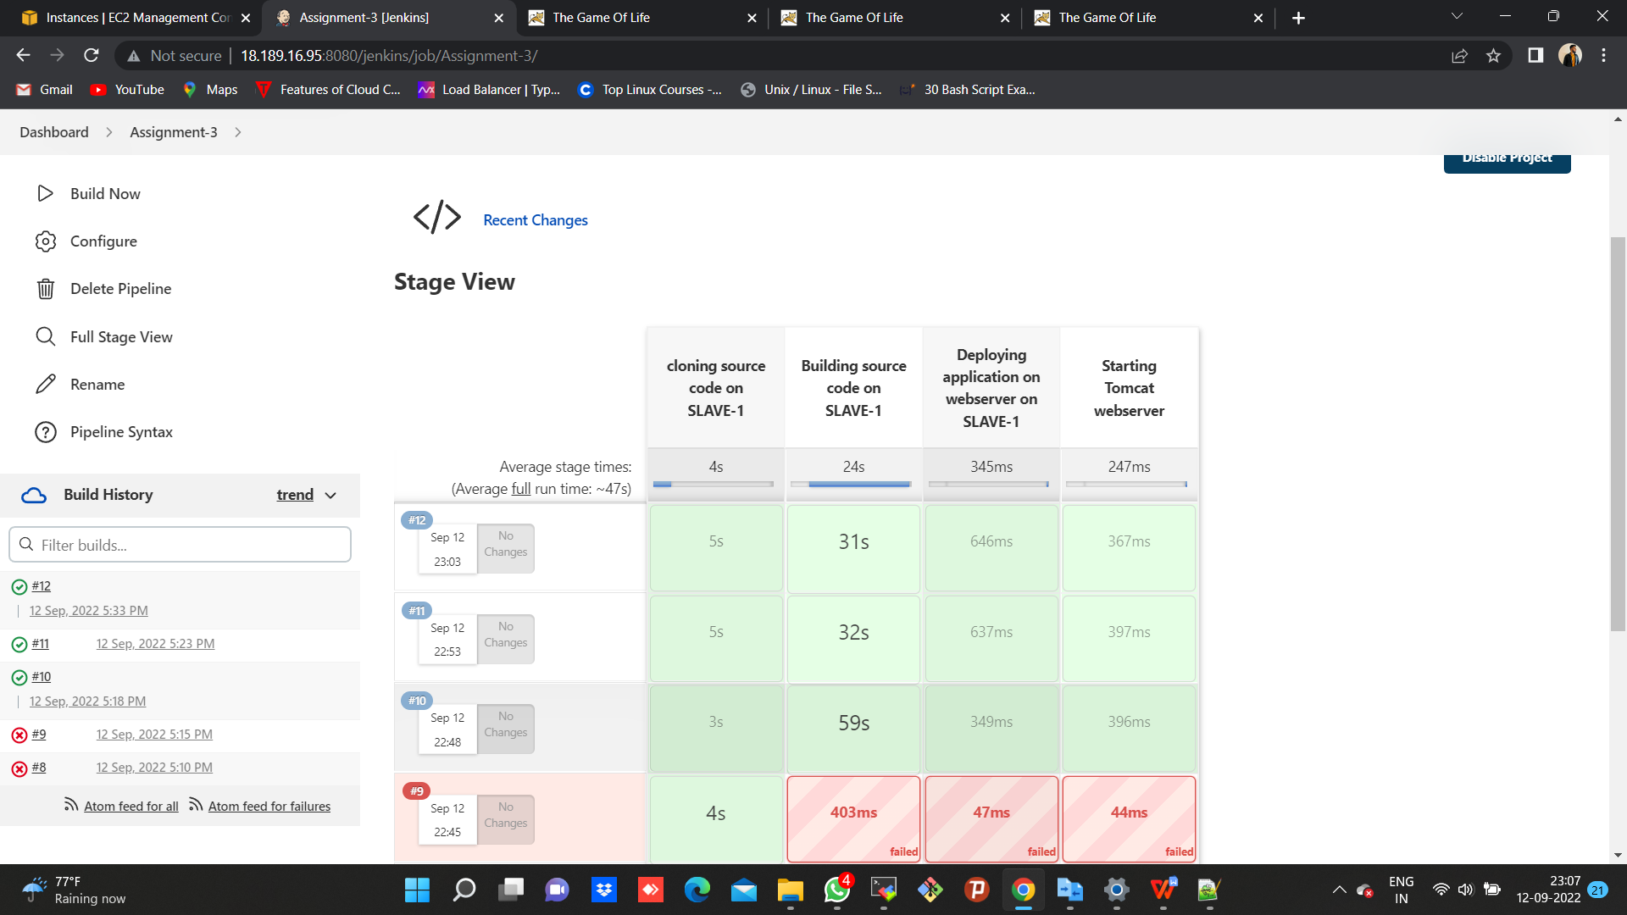

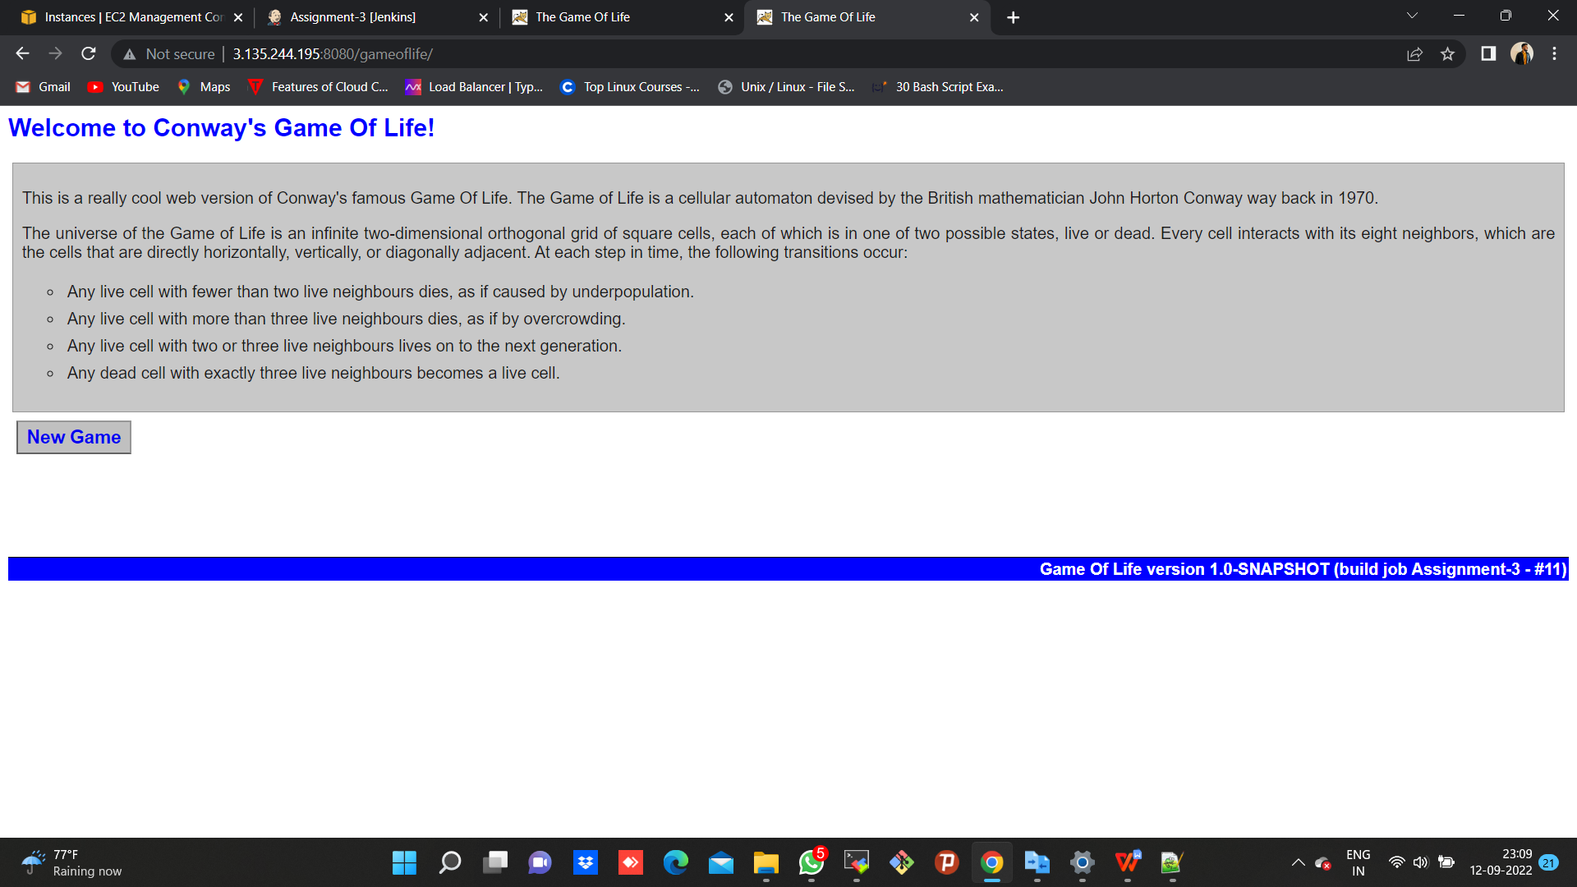

Slave-2:

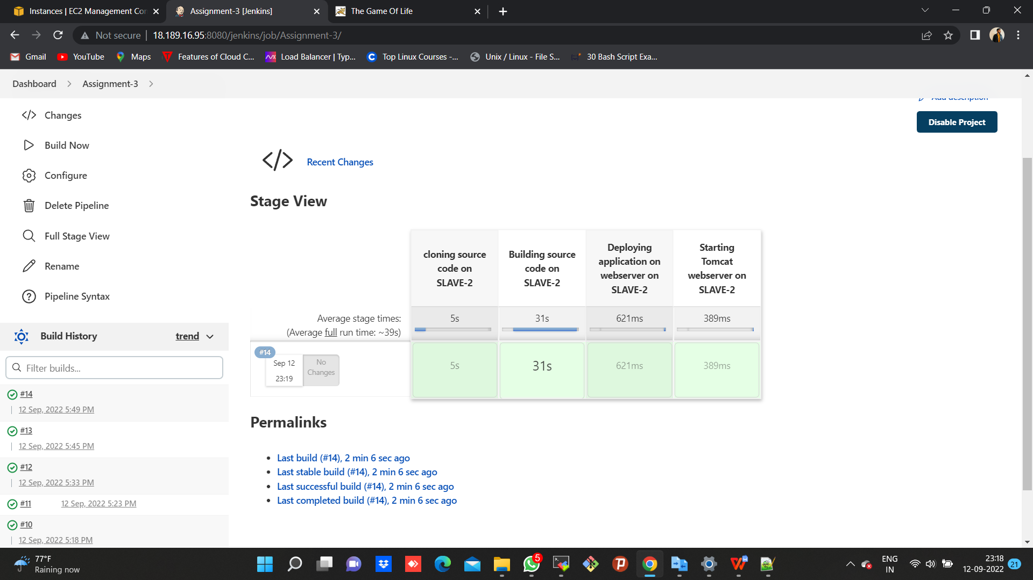

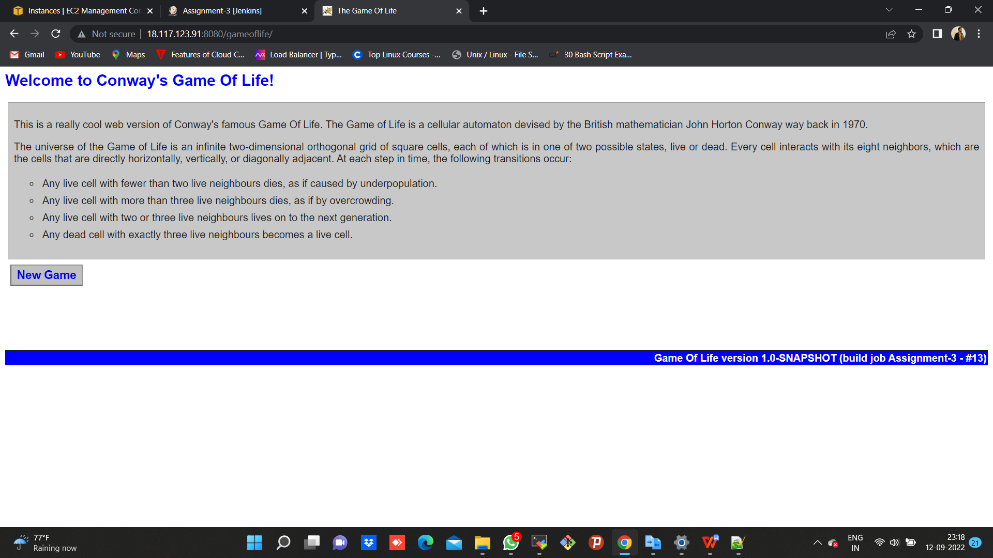

**CODE-SLAVE-1:**

pipeline {

agent {

node {

label "172.31.28.75-Slave-1"

customWorkspace "/mnt/projects"

}

}

environment {

PATH = "/mnt/build-tools/apache-maven-3.8.6/bin:$PATH"

}

stages {

stage ('cloning source code on SLAVE-1') {

steps {

sh "sudo rm -rf *"

sh "sudo yum install git -y"

sh "sudo git clone https://github.com/nupur-londhe/game-of-life-nup.git"

sh "sudo chmod -R 777 /mnt"

}

}

stage ('Building source code on SLAVE-1') {

steps {

dir ('/mnt/projects/game-of-life-nup'){

sh "mvn install"

}

}

}

stage ('Deploying application on webserver on SLAVE-1') {

steps {

sh "rm -rf /mnt/servers/apache-tomcat-9.0.65/webapps/gameoflife.war" //create this command as a comment when run for 1st time//

sh "cp -r /mnt/projects/game-of-life-nup/gameoflife-web/target/gameoflife.war /mnt/servers/apache-tomcat-9.0.65/webapps"

}

}

stage ('Starting Tomcat webserver') {

steps {

dir ('/mnt/servers/apache-tomcat-9.0.65/bin') {

sh "bash startup.sh"

}

}

}

}

}

**CODE-SLAVE-2:**

pipeline {

agent {

node {

label "172.31.30.34-Slave-2"

customWorkspace "/mnt/projects"

}

}

environment {

PATH = "/mnt/build-tools/apache-maven-3.8.6/bin:$PATH"

}

stages {

stage ('cloning source code on SLAVE-2') {

steps {

sh "sudo rm -rf *"

sh "sudo yum install git -y"

sh "sudo git clone https://github.com/nupur-londhe/game-of-life-nup.git"

sh "sudo chmod -R 777 /mnt"

}

}

stage ('Building source code on SLAVE-2') {

steps {

dir ('/mnt/projects/game-of-life-nup'){

sh "mvn install"

}

}

}

stage ('Deploying application on webserver on SLAVE-2') {

steps {

sh "rm -rf /mnt/servers/apache-tomcat-9.0.65/webapps/gameoflife.war" //create this command as a comment when run for 1st time//

sh "cp -r /mnt/projects/game-of-life-nup/gameoflife-web/target/gameoflife.war /mnt/servers/apache-tomcat-9.0.65/webapps"

}

}

stage ('Starting Tomcat webserver on SLAVE-2') {

steps {

dir ('/mnt/servers/apache-tomcat-9.0.65/bin') {

sh "bash startup.sh"

}

}

}

}

}